Supplies for Physical Science
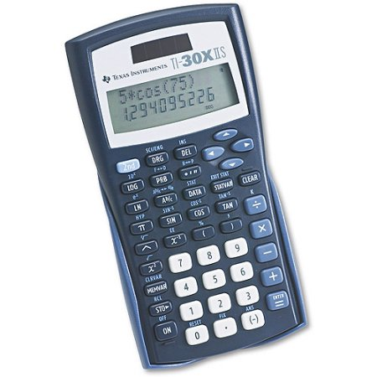

Texas Instruments TI-30X IIS Scientific Calculator: Walmart or Amazon $8.88
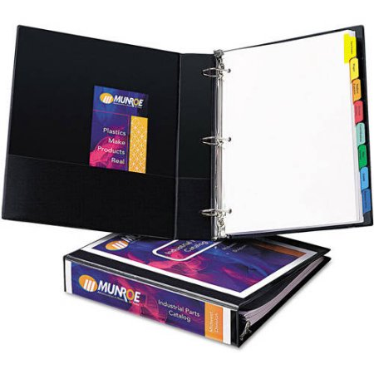

1-1/2" or 2” Three Ring Binder:

Walmart $4.88-$5.88 or Amazon $2.99-$4.79
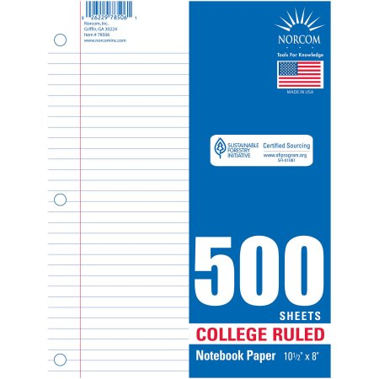

Loose Leaf Paper: Walmart $2.44

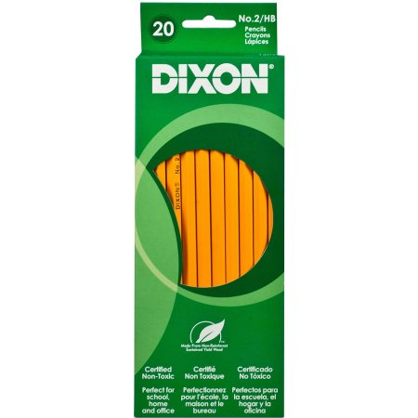

Pencils: Walmart $0.97

